***SEQUENCE DİAGRAMS OF USER***

***1-)Register***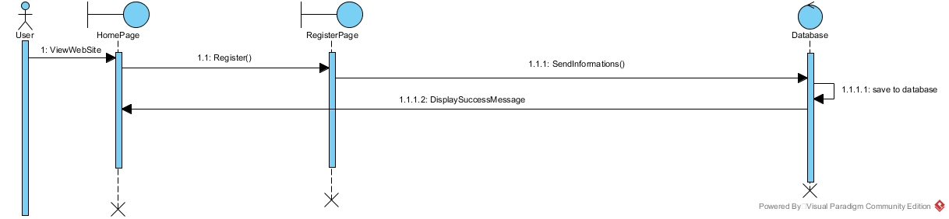

***2-)Login***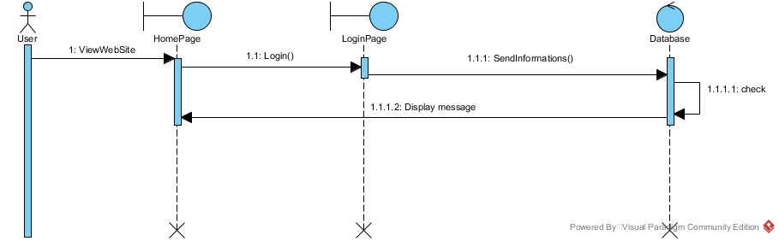

***3-)Searching Drugs***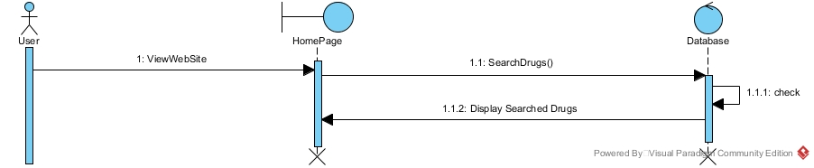

***4-)Add to Cart***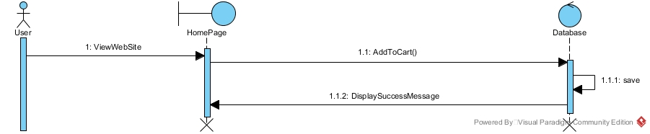

***5-)Buying***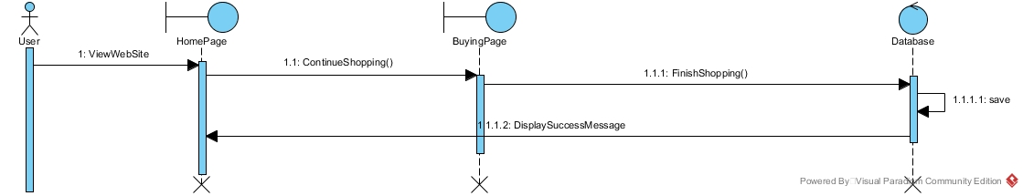

***6-)Cancelling Drugs From Cart***